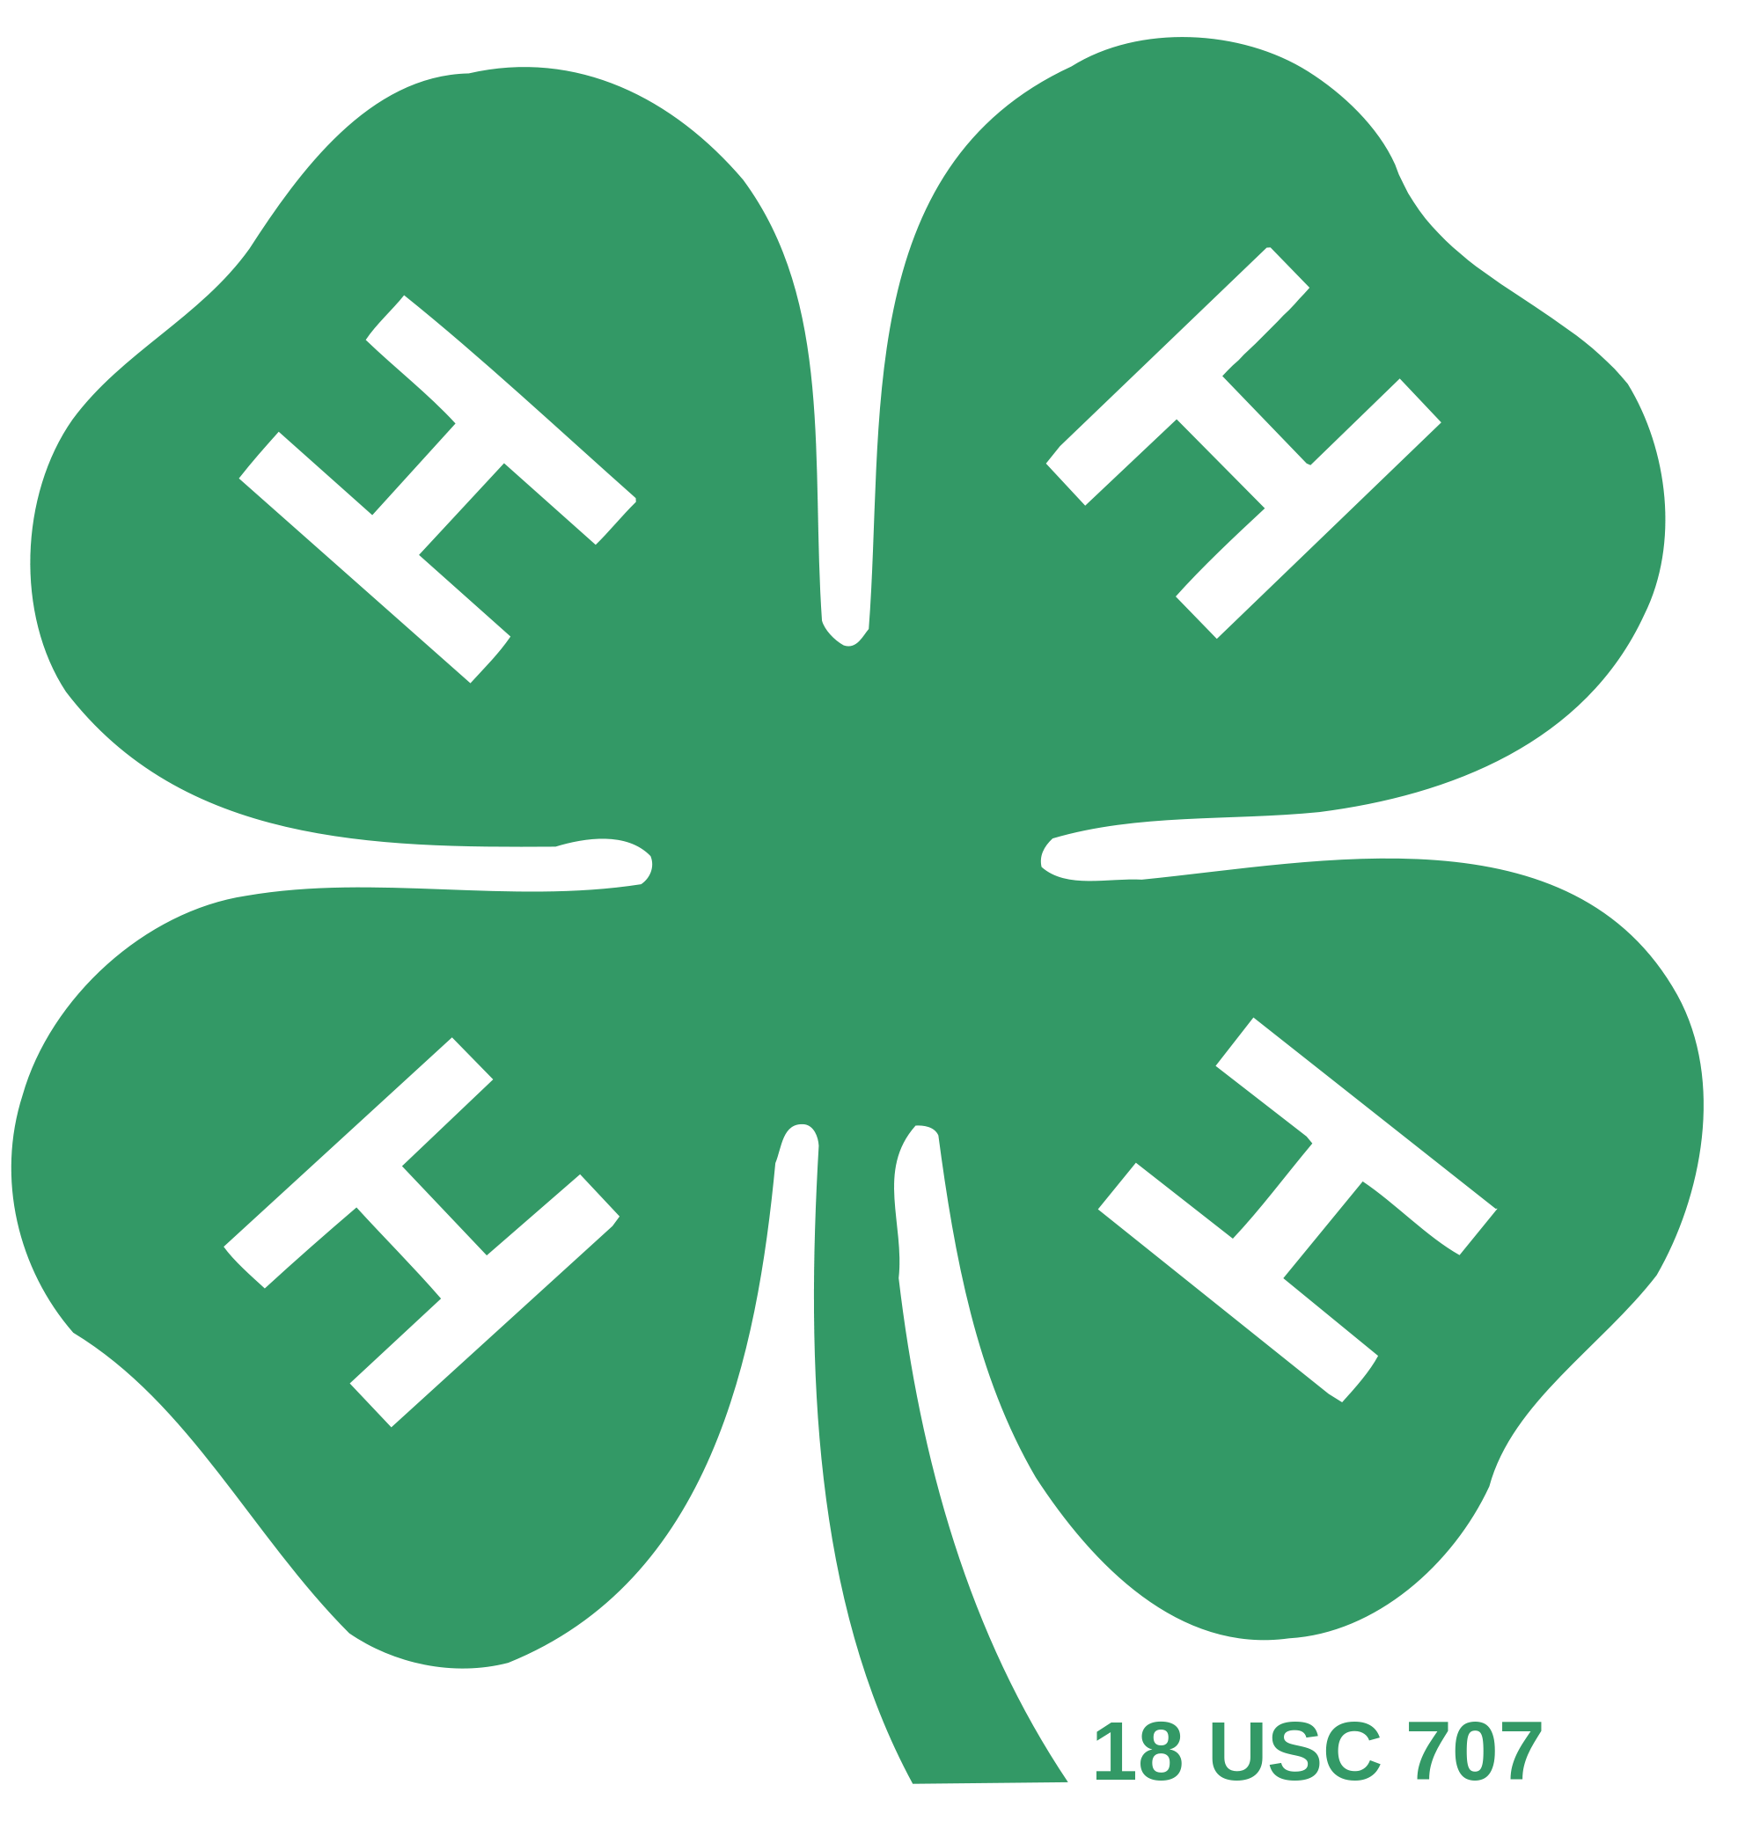

San Bruno/SSF Minutes

Date: 09/14/2016

* Preceding: Douglas Bernal (President)
* Call to Order: 07:18
* Flag Salute/4-H Pledge: Tristan Davis and Richard Shafhalter
* President’s Notes:
  + Welcome and introductions to the executive board and the other officers
* Treasurer’s Report:
  + Basic expenses/Other expenses
    - Total: $759.00

Gains:

* + - Total: +$1,932.00
  + Ending Balance
    - $29,595.42
* Recreation Report:
  + After the meeting we played Park Ranger
* Farm Report:
  + Farm rules/youth requests need to be turned in before October
  + Project leaders need a LiveScan
  + Farm Workday was Saturday, Sept. 17 from 10-3 PM
* Community Leader Report:
  + None
* Old Business:
  + - San Mateo County Fair!
      * Everyone who exhibited items shared what they brought
    - Fundraisers over the summer
      * Cake booth- was in a different location (we did awesome!!)
    - Yard Sale(s)- total: approx. $700.00 (we did well)
    - Pins!
      * Everyone who did a Record Book got their pins.
      * Note: Be sure to do your Record Books!!
* New Business:
  + - County Meeting was September 26, at 7:00
    - Farm Clean-up was September 17 from 10-3
    - Open House was September 18 at 1:00
    - We had some website changes w/t a new calendar and a new email ([sb4hwebmaster@gmail.com](mailto:sb4hwebmaster@gmail.com))
    - Enrollment is due! Will be collected at the farm clean-up and/or open house
    - Foosball Table!!
      * We went over the rules of the table’s use and the appropriate times to use it
    - Sweatshirts!
      * Committee sign-ups were after the General meeting along with project sign-ups
    - Plans/Goals of this year
      * Tabled-
    - Bee Project Decision
      * Project leader did not attend
      * Issues-over 20 hives→safety hazard
        + Swarming
        + Stings
      * Options
        + Keep all of the hives
        + Narrow down the hives to three (or)
        + Eliminate ALL bees
      * Discussion about the bees
        + Final decision: 2-1 vote the bees will be taken off the farm; more discussion with Todd needed
    - Birthdays!
    - Added topic:
      * 4-H Camp: everyone who went talked about camp (sounded like everyone had fun!)
      * Next year’s theme: Aloha!
* Next Meeting:
  + - October 12th at 7PM

Approved by: Your Secretary, Ryan Olson